THE DIFFERENT TYPES OF TOFU

You might be looking to add more tofu into your diet for health benefits.

But with so many different choices, ranging from silken to extra firm, how do you select the right kind for your need?

Keep reading, and I will share the nutrient profile of the different tofu and their culinary application.

First, let's look at the benefit of tofu and why you may want to include them in your diet.

The Benefits of tofu

High Protein Quality

Not all proteins are created equal. The quality differs depending on their amino acid composition, digestibility, and bioavailability. In other words, some protein sources have more essential amino acids and are more easily digested and absorbed than others. Due to this reason, animal protein sources are regarded as higher quality than plant proteins. The exception is soy protein, which is found in tofu, making it just as good as animal proteins.

Minerals and Phytochemicals

Tofu is also a source of minerals such as iron and calcium. And surprisingly, the absorption of these minerals from tofu is quite good despite phytate and oxalate, compounds preventing mineral absorption found in plant food.

Soy foods, rich in isoflavones, have pretty good evidence in reducing the severity and frequency of hot flashes and improving arterial health in menopausal women.

Other health benefits

According to a meta-analysis of clinical studies, consuming soy proteins is linked with lowering LDL-cholesterols in humans. Due to the robust evidence, Canadian health regulations even permit food manufacturers to make this health claim on soy protein products.

Given the low saturated fat content, ability to reduce triglyceride, high blood pressure, while increasing HDL cholesterol, tofu is truly a heart-healthy food you don't want to miss out.

The Myths about Soy

You may also have heard about controversies around soy. Luckily, these have never been proven to be true. Check out this article by registered dietitian Andy De Santis, debunking myths about soy and breast cancer, testosterone levels, and man boobs.

Now that we've covered the health benefits of tofu... let's look at the different varieties of tofu and how you can use them.

Protein and Calorie Content

 | Silken tofu | Soft | Medium | Firm | Extra firm | Flavoured Dried Tofu
Brand | Sunrise  400g | Sunrise 300g | Sunrise 454g | Sunrise 500g | Sunrise 350g | Sunrise 280g
Calorie | 40kcal/85g | 45g/85 | 70kcal/85g | 80kcal/85g | 130kcal/85g | 140kcal/85g
Protein | 4g | 5g/85 | 7g/85g | 9g/85g | 14g/85g | 15g/85g

Silken tofu & Soft

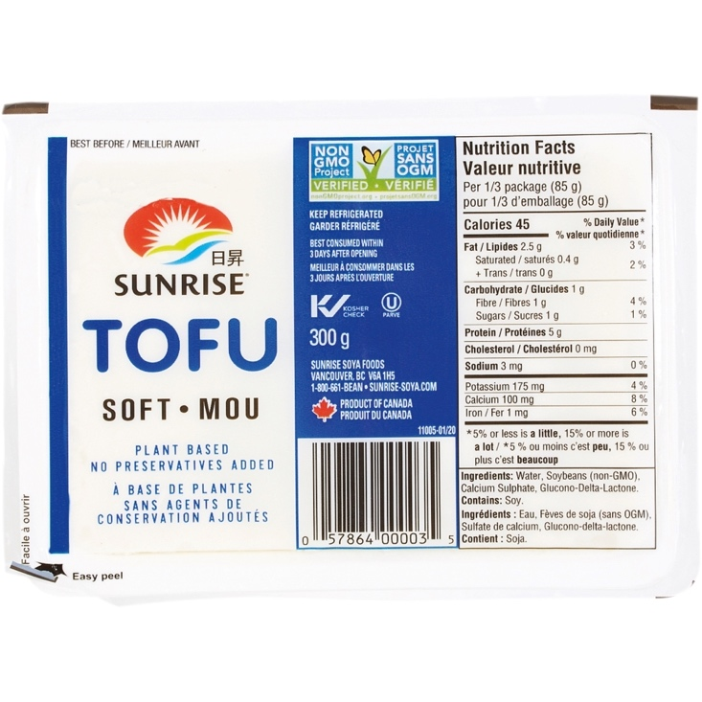

Description

I am clumping silken and soft tofu into one category because of similar nutrient content and overlapping culinary application. This tofu category is moisture-rich and delicate. It has the "melt in your mouth" texture. Handle this tofu very carefully when cooking with it if you don't want it to fall apart between your fingers.

Nutrition Comment

Given the high-water content of this tofu, they have much less protein than the firmer varieties. A whole package of 300g of soft tofu gets you less than 20g of protein. It means that silken and soft tofu isn't the most efficient kind for maximizing protein. However, due to the delicate nature of this tofu, it can help people like seniors who have a hard time chewing or swallowing hard food to eat more protein. Some people who prefer to avoid whey protein powder also add this tofu to their smoothie to boost protein.

Applications

- Smoothie
- Cold dish
- Braised

Sample Recipes

MaPo Tofu by Kaitlin from thewoksoflife.com

A spicy and meaty dish from Sichuan province in China. What is unique about this dish is the Sichuan peppercorn which produces a tingling and numbing effect on the tongue and throat. Some have described the numbing effect as "ants crawling in the throat." Now, ants crawling doesn't sound super enticing! But trust me, it's savory, spicy, and full of umami! That's how this dish becomes the hallmark of Sichuan cuisine.

Tofu Smoothie

A google search will get you tons of recipes using silken tofu to boost the protein in smoothies.

Tofu with Century Egg (a cold side dish) by Auntie Emily's Kitchen

This recipe resembles what I ate growing up in Taiwan. It best goes with congee or a bowl of noodles.

Medium Firm

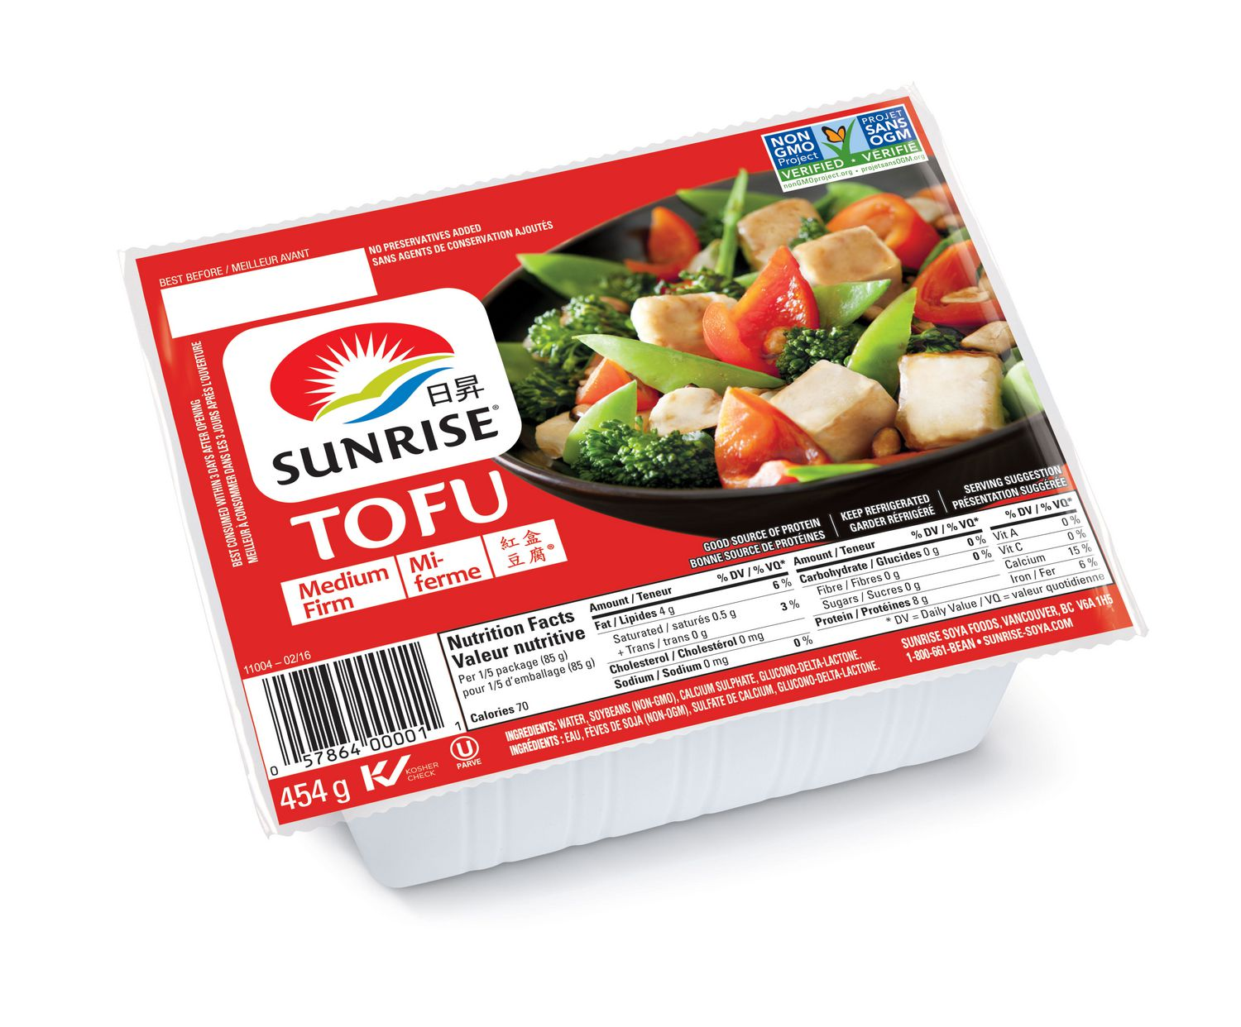

Description

It is much easier to handle compared to soft/silken tofu, but it can still break between your fingers with slight force. Because its firmness sits in the middle across different types of tofu, it's got a broad set of cooking applications. You can likely substitute firm tofu recipes with a medium-firm, and it will still be ok!

Nutrition Comment

Almost doubled the protein of silken tofu. Half a package can get you nearly 20 g of protein. Eating it along with grains and vegetables will get you enough protein for a meal. This tofu is often crumbled or blended in vegan and non-traditional recipes, such as hummus, cream sauce, tofu scramble, and desserts.

Applications

- Deep-frying
- Pan-fry
- Braised
- Non-traditional applications

Sample Recipes

Maangchi's Spicy Braised Tofu

I have made this recipe countless times - my personal favorite. It's quick to make and goes well with plain rice. I have also made the same recipe with firm and extra-firm tofu, and it works just as well! It shows that tofu recipes can be forgiving with the types of tofu.

Firm

Description

This tofu is easy to handle. No need to fear breaking it during cooking. It is very suitable for stir-frying that needs lots of turning and tossing. Because of its firm texture, it does not pick up flavors as well. The trick is to cut them into smaller or thinner pieces to create more surface area for sauce and seasonings to cling on.
Pan-frying them until golden brown will bump up their flavor and create a rougher surface to grab onto more sauce.

Nutrition Comment

A whole package gives you 53 g of protein. Half a container will likely give you enough protein for the meal.

Application:

- panfry
- deep-fry
- braising

Recipes:

General Tso Tofu by Seonkyonglongest

Seonkyonglongest used an air fryer to get the tofu golden brown before cooking them in a tangy, sweet, spicy sauce. Don't worry if you do not own an air fryer. Just pan fry the tofu until golden and proceed with the rest of the recipe.

Extra-firm

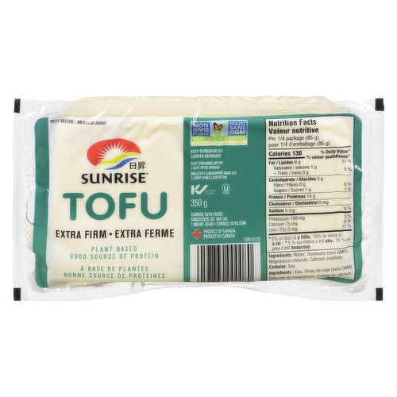

Due to the low moisture content, the texture of extra-firm is drastically different from the softer varieties. This is my personal favorite because it's dense, got lots of chew, and makes me feel fuller (perhaps related to both the chewing and the higher protein content). The application of firm and extra-firm isn't too different.

Nutrient Comment

A whole package of extra-firm tofu gives you almost 58g of protein. Though it does not look like a lot more than firm tofu (53g), a package of extra-firm is only 305 g, while a package of firm tofu is 500 g. So it means you're getting more protein for eating less tofu.

Recipes
Sesame Garlic Tofu by Julie Chiou

This sweet and savory tofu recipe is perfectly kid-friendly if you reduce or remove the chili. Julie used extra-firm tofu in this recipe but using firm tofu will be just as tasty!

Lemongrass Tofu Banh Mi by Seonkyounglongest

Seonkyounglongest, like me, also obsessed with Vietnamese food, made a vegan banh mi using extra-firm tofu. The most complicated part of this recipe is making the vegan pate, which you can substitute with a non-vegan pate if you are not vegetarian.

Bean Curd

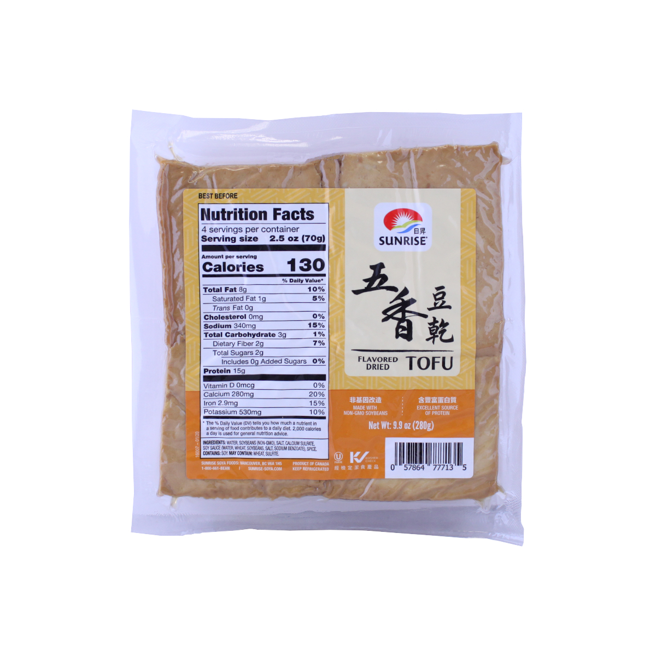

Description

Usually found in Asian or Chinese grocery stores in a transparent vacuum seal, white or brown. The brown color means that it has sat in a braising liquid infused with five-spice. Even if it is brown, it's still relatively flavorless, so you don't need to worry about its original flavor tempering with your recipe. It's most often used in stir-fries. Some people who really want to put in the effort will braise the tofu to soften and flavor it more before stir-frying.

Nutrition Comment

The protein content is very similar to extra-firm tofu. It is a good source of calcium and iron (this will depend on the brand of course). Definitely, an excellent choice if you are trying to bump up the protein in your diet.

Application

- Stir fry

Recipe:

Shredded Pork with Bean Curd by thewoksoflife.com

This recipe will show you the basic steps of cooking with bean curds. The recipe's author only cooked the bean curd with the veggies for just a minute. This is because browning the tofu for too long (unlike the other recipes I shared) will dry it up even further, making it too hard to chew. Of course, this is their personal preference. Some recipes will fry the bean curd to give it a nice crust before stir-frying.

After reading this blog, I hope you are ready to reap the benefits of soy protein and give these recipes a try!

This blog post is written by Evan Huang-Ku, a registered dietitian helping to incorporate your favorite cultural food into a healthy diet.

